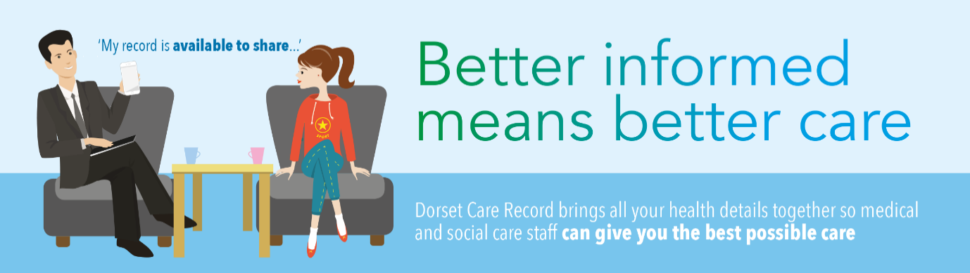

GP Connect Live in DCR

Dear DCR User

We have successfully introduced a new way to get Primary Care (GP) Information in DCR. The GP Connect system is replacing the current MIG system.
Among the benefits will be:
- Richer information with more detailed notes and readings
- A broader level of information being exchanged
- An easier way to facilitate new information being added – as the GP Connect standard evolves, additional information will be displayed automatically.
You will find information stored in the Clinical Document View under the summary tab rather than the GP Record tab. The categories may be different but the content is all there. We have produced a short video explaining what you will find in the tab.
Dorset Care Record and GP Connect – YouTube
We have also provided a Frequently Asked Questions page on our intranet - https://news.dorsetcouncil.gov.uk/dcr-staff-area/2021/02/28/gp-connect-frequently-asked-questions/

Thanks

DCR System Admin

